CRICKSTATS – SALESFORCE CAPSTONE PROJECT
PHASE 1 – BRAINSTORMING AND IDEATION
CRICKET PLAYER PERFORMANCE TRACKING APPLICATION
Information | Details
Project Title | CRICKET PLAYER PERFORMANCE TRACKING APPLICATION  CRICKSTATS
Project Domain | Cloud Computing / Salesforce Administration
Platform | Salesforce Lightning Developer Edition
Team Leader | Saravanan S - (Reg. No. 24134031802521044)
Member 2 | SRIVARSHAN S- (Reg. No. 24134031802521048)
Member 3 | Tamilselvan S- (Reg. No. 24134031802521051)
Member 4 | Karthi Karthi- (Reg. No. 24134031802521020)
Member 5 | Barathiraja R- (Reg. No. 24134031802521013)
Institution | PS PT MGR GOVERNMENT ARTS & SCIENCE COLLEGE, SIRKALI, PUTHUR-609108 (College Code: ANM403)
Submission Portal | SkillWallet / Naan Mudhalvan

1. User Story
As a Salesforce Admin, I want to create a comprehensive player performance tracking application within Salesforce to capture and analyze detailed match-by-match information of cricket players. The application includes Player and Match Performance custom objects, defined fields and relationships, reporting and analytics.

2. Project Overview
CRICKSTATS is a Salesforce-based application designed to track, manage, and analyze cricket players’ performance on a match-by-match basis. It uses custom objects, relationships, dashboards, and automation tools to provide structured performance insights.

3. Purpose
- To digitize player performance records.
- To improve accuracy and accessibility of cricket statistics.
- To provide real-time analytics.
- To support player development and team planning.
- To automate data management using Salesforce.

4. Problem Statements
PS | Customer | Trying to | But | Because | Makes me feel
PS-1 | A cricket team coach | Track player performance across matches | Cannot get accurate statistics easily | Data is stored in different files and formats | Frustrated and unsure about team selection
PS-2 | A team manager | Maintain complete player records | Takes too much time to update and verify data | Most records are maintained manually | Stressed and inefficient
PS-3 | A sports analyst | Analyze player trends and generate reports | Difficulty comparing performances | No centralized analytics system | Confused and dissatisfied

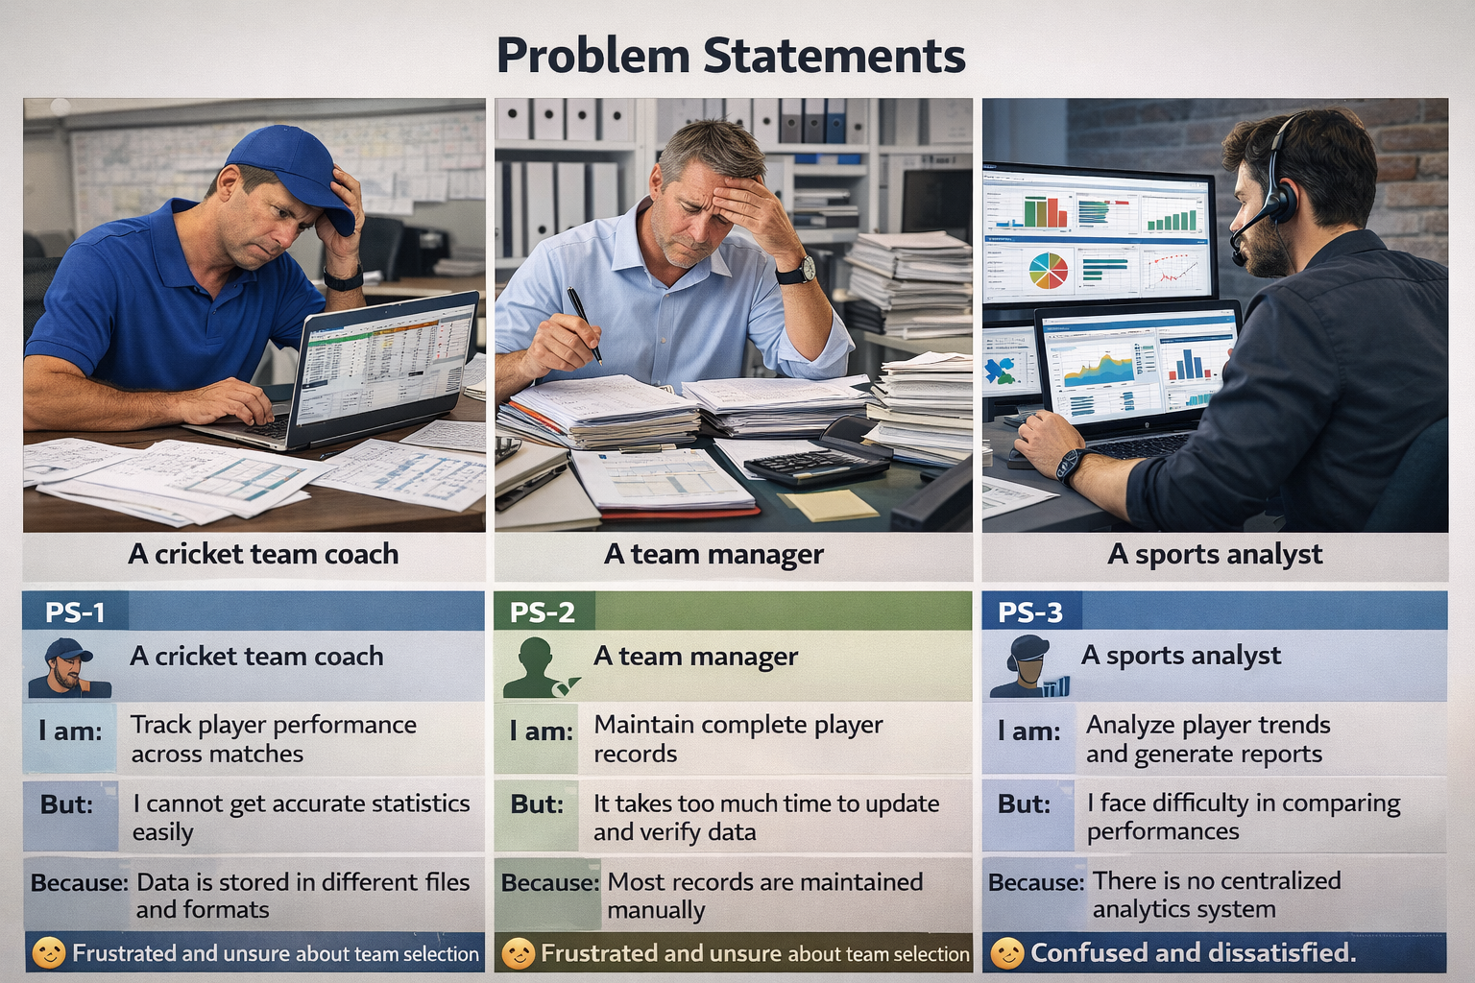

5. Empathy Map Canvas
Aspect | Description
Target Users | Team Managers, Coaches, Analysts, Salesforce Admins
Think & Feel | Need accurate data, better insights, precise player stats and better analytics tools.
Hear | Feedback from management to ensure decisions are data-driven and improve team performance.
See | Multiple data sources, scattered spreadsheets, different formats and disconnected systems.
Say & Do | Collect statistics manually, update records personally, and constantly check data.
Pain | Data errors, delays, inconsistent statistics and wasted hours verifying information.
Gain | Faster decisions, automation, centralized analytics and reliable reports.

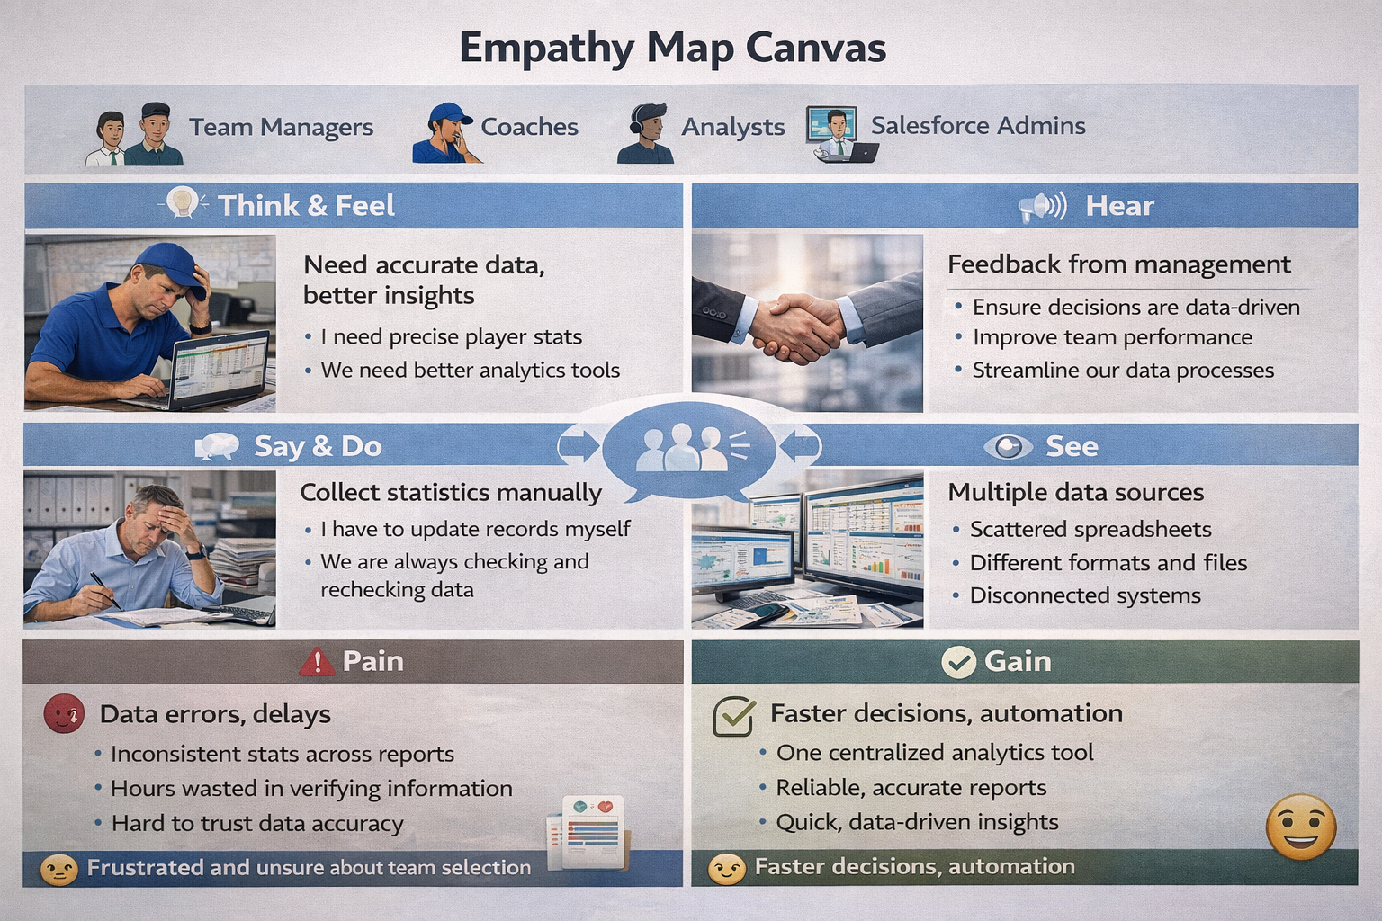

6. Brainstorming & Selection
- Web-based player management system
- Mobile statistics tracker
- Salesforce-integrated CRM
- AI-based performance prediction
- Dashboard-based analytics
Selected Idea: Salesforce-based performance tracking platform (CRICKSTATS).
Selection Reason: Combines a secure cloud relational database, master-detail roll-up summarization, interactive Lightning user interfaces, and dynamic screen flows in one workspace.

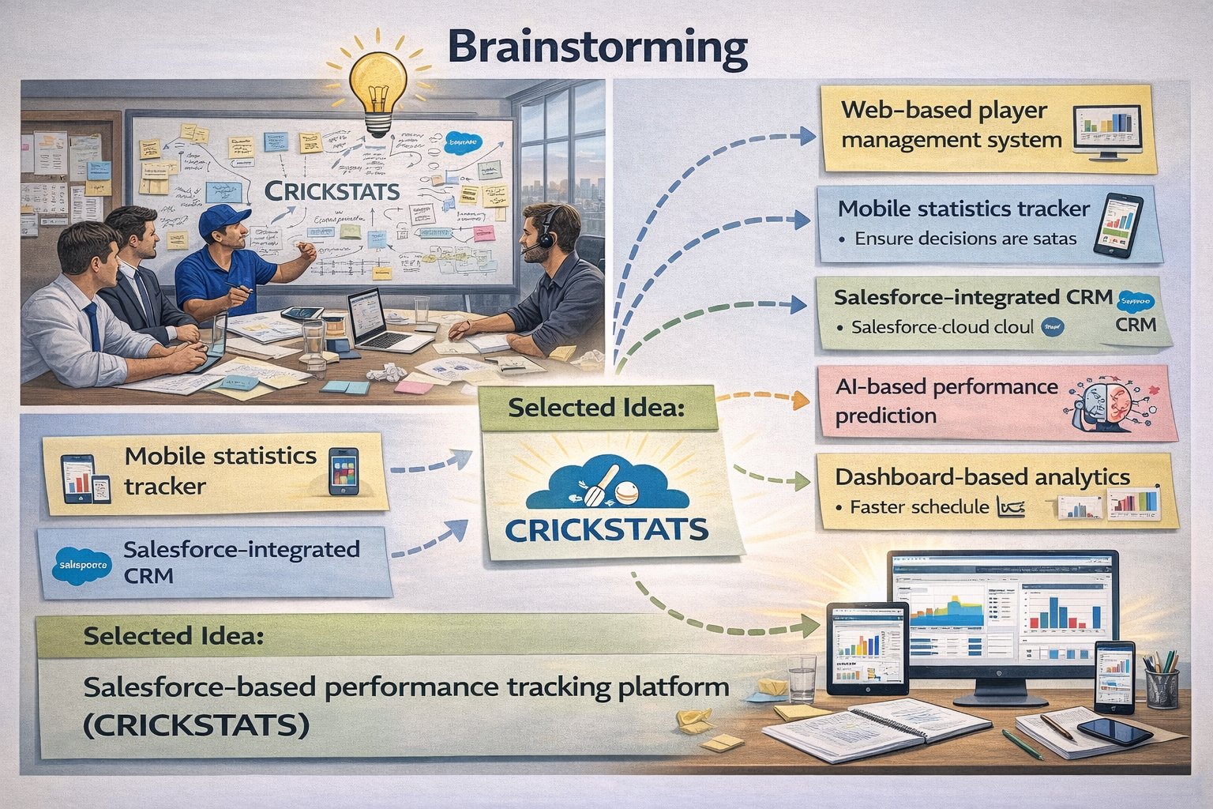

7. Phase Conclusion
The ideation phase identifies the main problems, user needs and possible solutions and selects CRICKSTATS as the Salesforce-based performance tracking platform.

